REPORT OF THE VISIT OF THE WESTERN REGIONAL CO-ORDINATOR OF THE DOMINICAN SISTERS AFRICA (DSA) SR. MARTHE ABADOHOUE, OP BETWEEN 1ST AND 3RD NOVEMBER,2025 TO THE CONGREGATION OF THE DOMINICAN SISTERS OF ST. CATHERINE OF SIENA, GUSAU, NIGERIA HELD AT MABERA COMMUNITY, SOKOTO, SOKOTO STATE.
BEGINNINGS:
1st Day... November 1st: Arrivals
The Co- Ordinator- Sr. Marthe Abadahoue, OP. , The Prioress General- Sr. Justina Nnajiofor OP, The DSA Representative for the Congregation- Sr. Mary-comfort Okoro, OP and other sisters from Gusau, Birnin Kebbi and 2 communities in Sokoto arrived safe and sound to the venue of the meeting.
At 6:30pm in the evening, we had a Spirit filled evening prayer which was followed by meditation, exchange of pleasantries and a beautiful supper. We then retired for the day.
The 2nd Day - November 2nd:
The day started with Holy Mass which was well celebrated at the Church of Our Lady of Perpetual Help, Old Airport Sokoto at about 6:00am officiated by Rev. Fr. Jude Okpanachi, the Parish Priest. The homily stressed on the three groups that make up the Church of Christ namely...the Church Triumphant, the Church Suffering and the Church Militants. He told us that the first group who are the Saints have already gained the crown in heaven after withstanding the tribulations of this world, the 2nd group- the Souls in Purgatory, constitute the Church Suffering and depend completely on our prayers as they can no longer prayer for or help themselves, and the 3rd group-the Church Militants who constitute we who are still alive and are engaged in a daily battle with the devil, sin and evil. He called us to seek the help of the Saints through prayers, arms giving and holy lives so that we will be able to triumph as they have done; and also encouraged us to pray incessantly for the souls of our beloved dead who depend on our good will, charity and prayers. He warmly welcomed us before and after the Mass and took pictures with us. 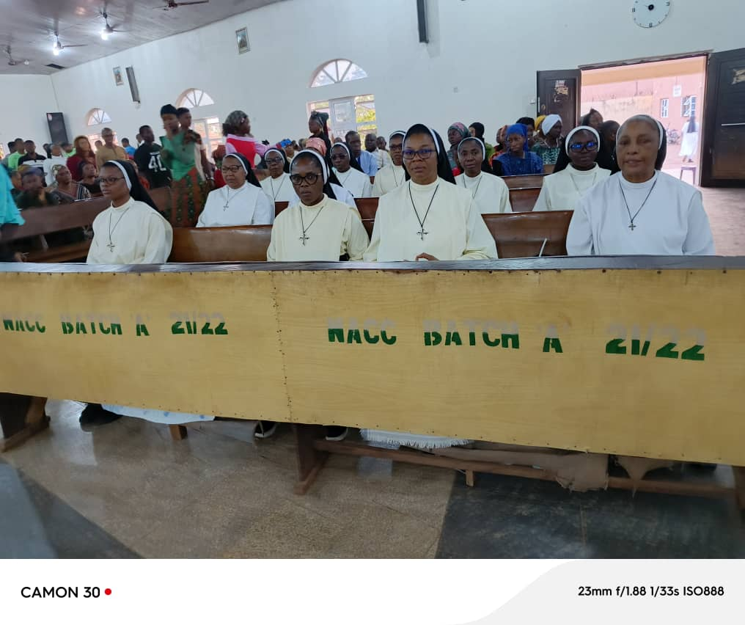
Meeting:
The session started with an opening prayer led by Sr. Edith Amaechi,OP at 9:30am after breakfast.
After the opening prayer, Sr. Mary-comfort welcomed all the sisters and gave brief rundown of the history/ origin of the Congregation of the Dominican Sisters of St Catherine of Siena Gusau Nigeria. In her speech, she spoke about their Apostolates and communities stating that the initial work/ engagements of the sisters were health, catechesis, women education and rural development which was targeted at the rural poor, especially women, children and youth covering areas like Gusau in present day Zamfara State, Funtua, Malumfashi and Katsina town in Katsina State, Yelwa- Yauri and Zuru in Kebbi State in the early 60s, 70s and 80s. But as the years went by, they increased in number and spread to other towns and cities within and outside Nigeria which includes- the Arch-diocese of Jos, Dioceses of Kontagora, Makurdi, Enugu and Issele –Uku. Others include the Archdiocese of Abuja –FCT. Dioceses of Awka, Gboko and Lokoja. Furthermore, we have Communities in the Northern States of Sokoto, Zamfara, Kebbi, Katsina and Kaduna. We are also on mission to Ghana, United States of America (USA), Austria, Rome, Ivory Coast and previously in Grenada.
Challenges:
In her speech, she mentioned some of the challenges they face such as Islamic insurgency and fundamentalism, banditry, harsh economy and poverty of parents such that they are not able to pay their wards school fees and other provisions.
Impact on the lives of the local people: Lastly, she stated that the Congregation has impacted the lives of the local communities through their engagement in primary evangelization, Christian presence in the Northen region of the country, education of their people, health care services, justice and peace interventions and other forms of empowerment through workshops and the acquisition of skills.
Once again, she thanked the sisters for their presence and for listening attentively. .
Speech by the Co-ordinator- Sr Marthe Abadahoue, OP
The West regional Co-ordinator in her speech, thanked the sisters for their warm and fraternal welcome. She went ahead to say that this visit of hers is an opportunity for her to get to know the sisters in Nigeria, to see the reality of their mission and to encourage synodality/ collaboration and walking together among the different components of the Dominican family in Nigeria and to share with us our experiences of the Dominican Family and exchange with us their concerns and expectations regarding the movement in Africa, and especially in Nigeria. To her, this is a movement of Dominican Sisters of Apostolic life and therefore, it concerns us all.
Interactive Session
Some questions were coined out from Sr. Marthe's presentation. Such include:
1. What is the quality of our relationship as members of the Dominican Family today?
2. How can we live synodality among the members of the Dominican Family?
3. Seeing the realities and challenges related to justice, peace and integrity of creation, how can we work together to advance our common mission?
4. Can we think together about some projects that we can do jointly in order to revitalize and make a little more visible impact on our society?
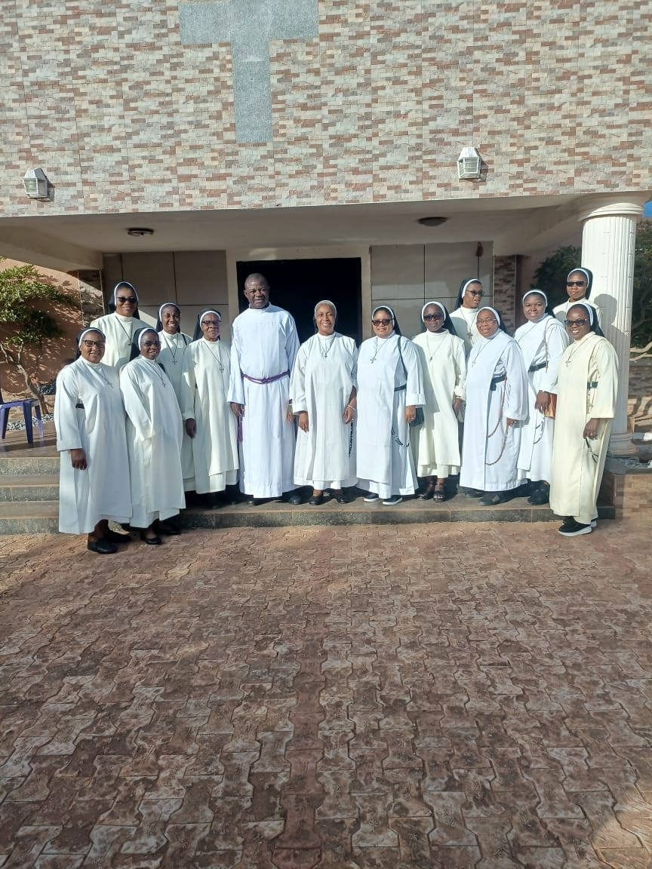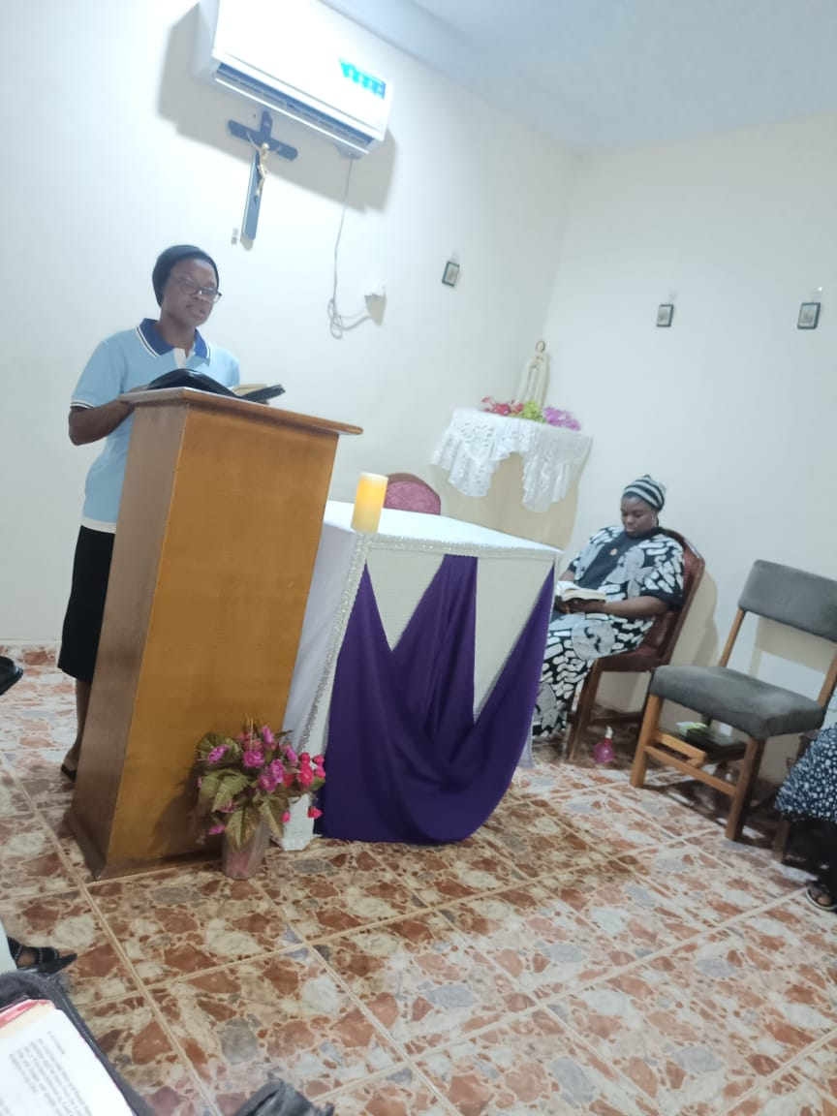
Group Picture after the Mass During Evening prayer 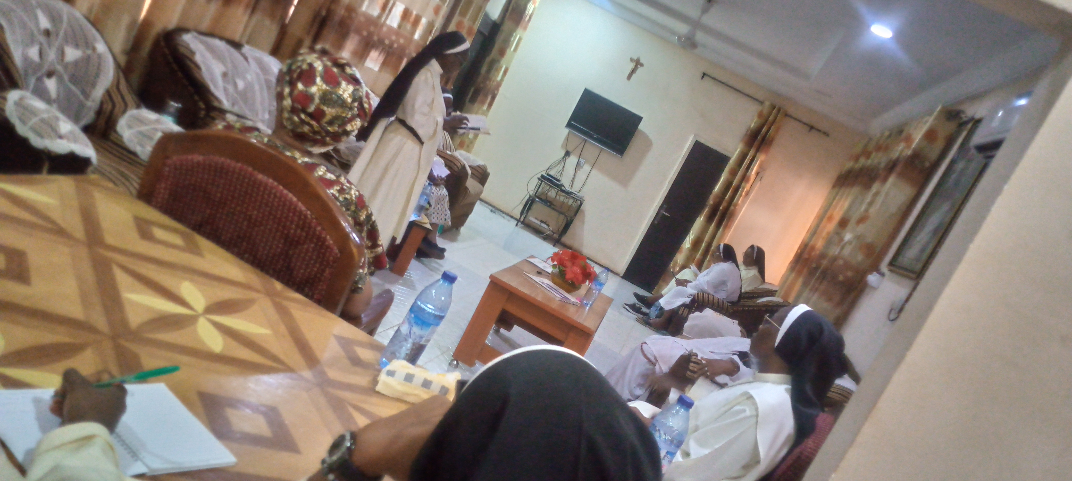 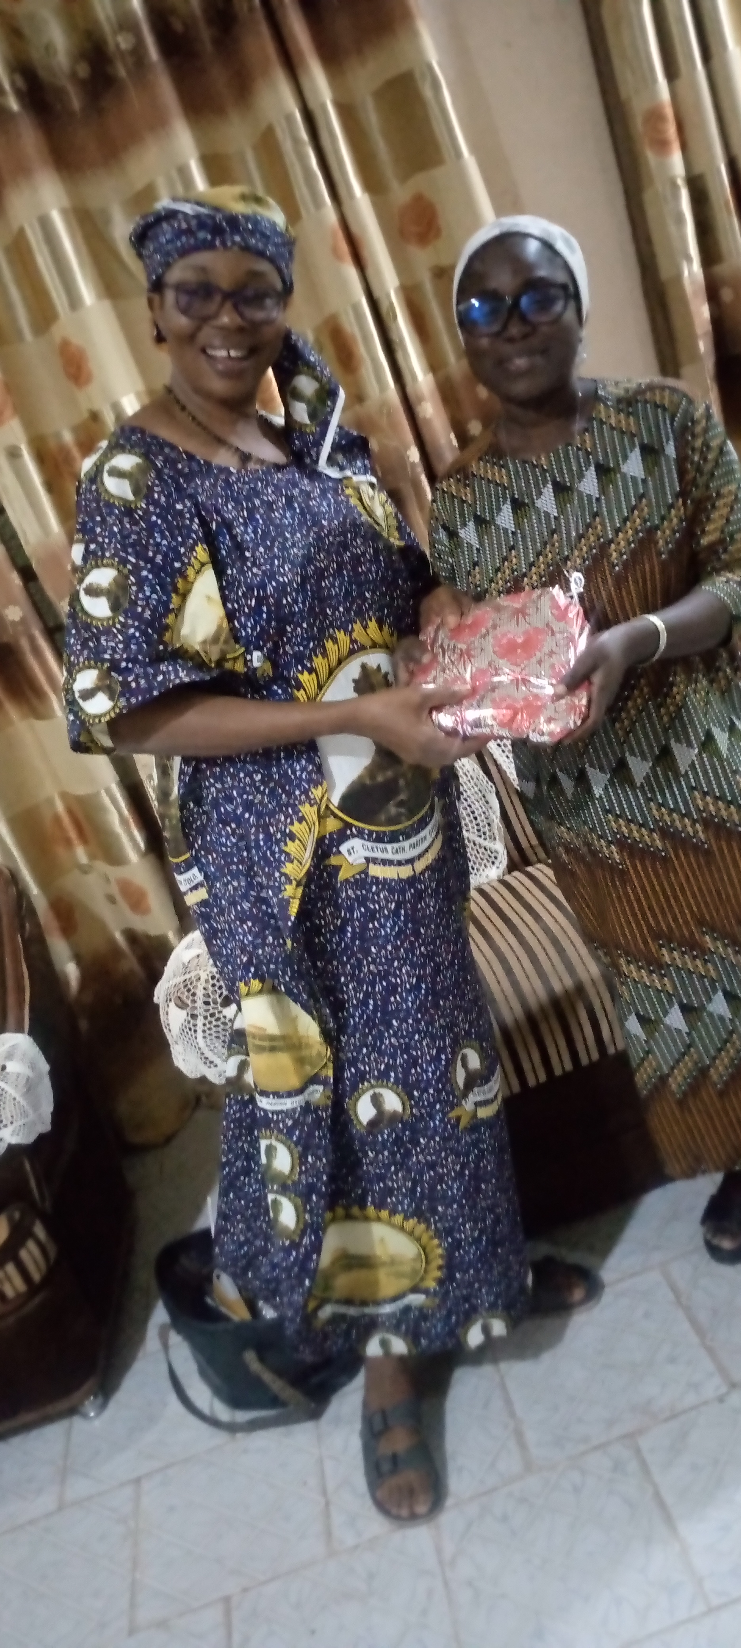
Sr. Marthe Abadohoue, OP presenting her speech The Prioress- presenting a gift to Sr. Marthe.
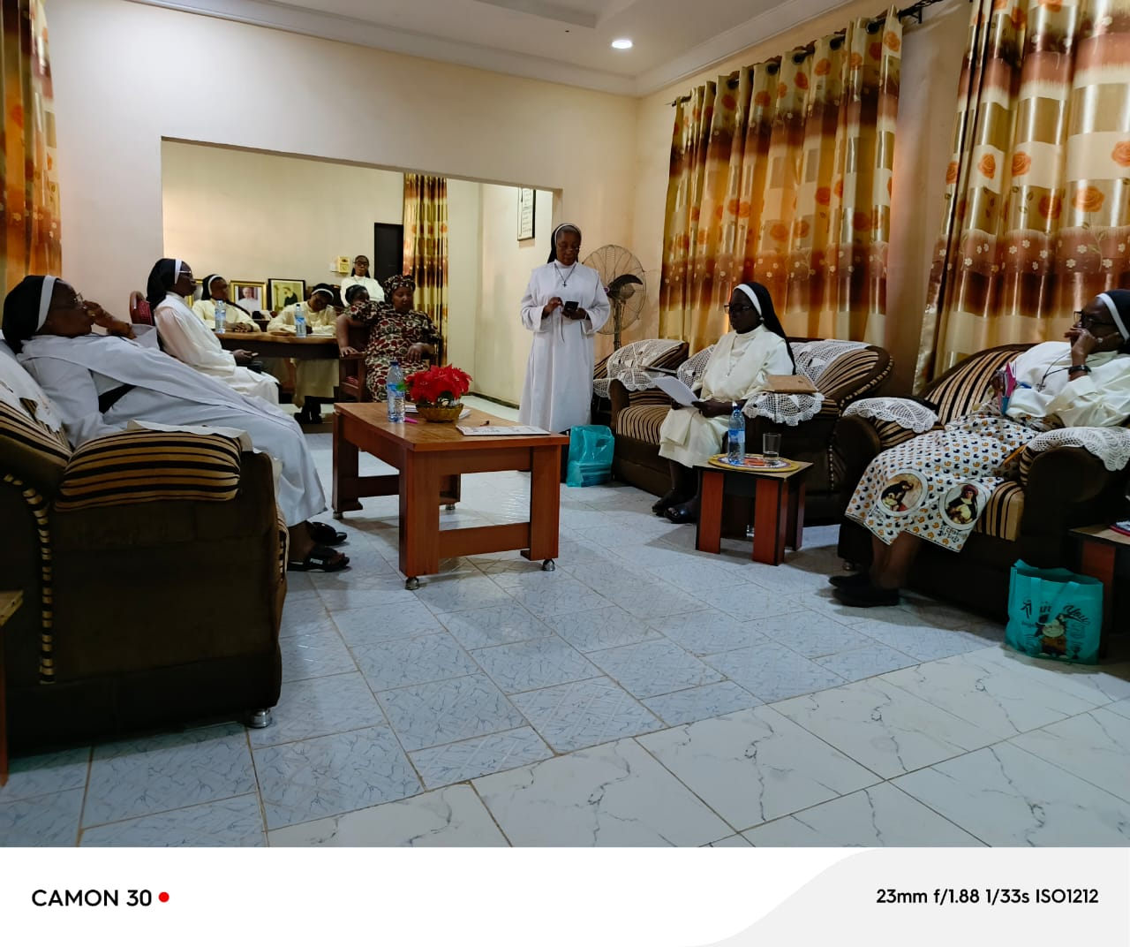
Sr. Mary-Comfort Okoro, OP presenting a speech to the House

The following Responses were given:
In response to questions numbers 1,2 and 3, the Prioress General, Sr. Justina Nnajiofor OP said that on her part, she has been in communication with the other Prioresses and leaders of the other two Dominican Congregations in Nigeria, the Dominican Sisters of St Catherine of Siena, Ibadan , Oyo State and the Dominican Sisters of Pompai based in Mbaise, Imo State. In being constantly in touch with them, the hope and tendency to continue to be in synodality as a family is very high.
In response to question number 4, we responded that the 3 members of the Dominican Family mentioned above recently and jointly organized and conducted a workshop at Abuja between 18th and 19th September, 2025 by the JDPC arm of the three (3 ) Nigerian Dominican Congregations under the auspices of the Justice, Peace Development Department of DSIC . The title was “ A training Workshop for Rural Women on backyard gardening to address the impact of climate change variability on food security”. This was aimed at empowering the rural dwellers on how to maximize the little spaces they have in order to grow edible plants that will help to increase their level of food security.
Attached are some of the pictures.
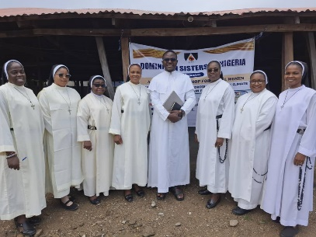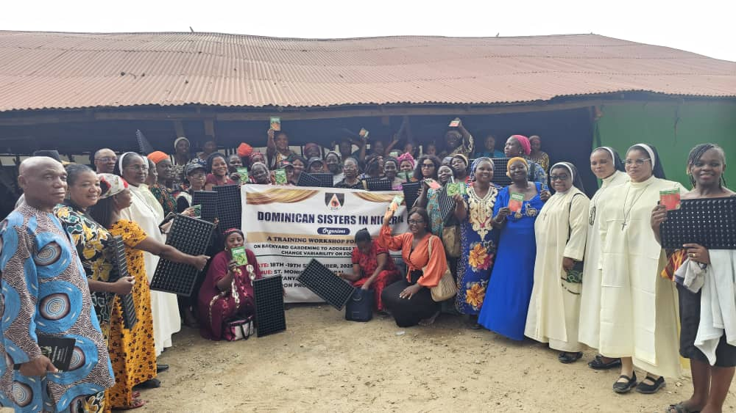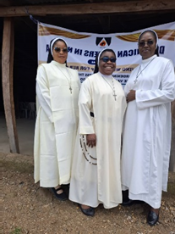

Furthermore, Sisters suggested that some of the other ways to promote synodality among the 3 Congregations are:
1. The Prioresses of the different Congregations should meet more often mostly through zoom or any other form of online meeting to save cost and to avoid kidnapping due to high rate of insecurity. They are to meet to sharpen the level of friendly relationship existing between them, to share experiences, joys and challenges in order to proffer solutions to their challenges.
2. The 3 Congregations can partner by organizing joint Novitiate program for Sisters in initial formation.
3. They can also organize same programs for Sisters in ongoing or temporary formation and even for those that are finally professed once a year or thereabout.
4. They could also think of other programs apart from those already mentioned like organizing Formators Course for our Formators etc.
Sisters were given the freedom to ask some other personal questions to know more about Sr. Marthe Abadahoue OP and her Congregation, their origin, apostolates , population, years of existence and much more others.
Vote of thanks:
At the end, Sr Marthe gave her vote of thanks by thanking the Sisters for the warm welcome given to her and prayed for the continuous success of the mission of our congregation in this frontier.
Closing Prayer:
The meeting came to a close at about 11:30am with closing prayer said by Sr. Ann An-iko,OP. We then proceeded to have an early lunch to enable the sisters attend 12noon Mass in honour of the Departed Souls.
Evening session:
We gathered again in the evening at 6:30pm for evening prayers and for supper. We exchanged pleasantries and had a beautiful time together. A gift was presented to Sr Marthe by the Prioress General and thanked her for taking the risk to come to visit and encourage us.
Closing:
The closing Prayer was said by Sr. Marthe Abadahoue OP at about 9pm and everyone left for their places of rest and communities.
The Sisters present were:
- Sr. Justina Nnajiofor, OP
- Sr. Marthe Abadahoue, OP
- Sr. Mary-comfort Okoro, OP
- Sr. Elizabeth Okpechi, OP
- Sr. Ann An-iko, OP
- Sr. Edith Amaechi, OP
- Sr. Kate Okolocha, OP
- . Sr. Sylvaline Obiezughara, OP
- Sr. Benadette Okafor, OP
- Sr. Edith Igboanugo, OP
- Sr. Callista Agbokwor, OP
- Sr. Vivian Mbaku, OP
- Sr. Florence Nkwegu, OP---Secretary
- Sr. Faithmary Nor, OP---Secretary
Note:
Only these few Sisters who lived nearer to Sokoto could attend this meeting because of distance and insecurity.

Signed by:

Sr. Mary-comfort Okoro, OP
DSA Representative

